**Lab 3**

1. Adjust the histogram of the following image to match the reference image using histogram matching. Show the histogram of original, reference, and output images.

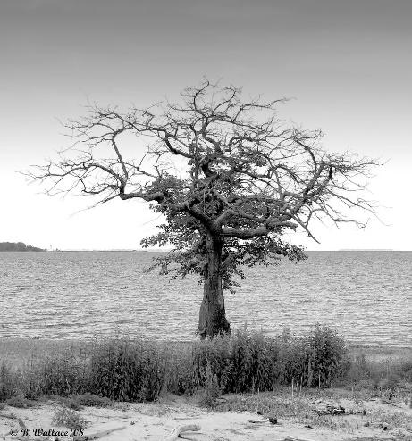 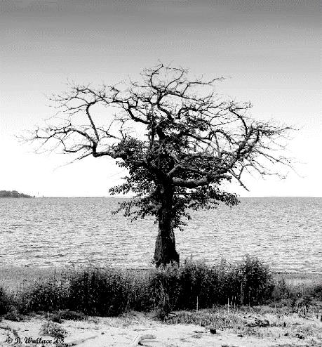

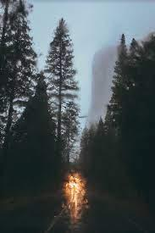 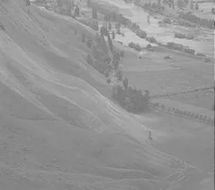

1. Change the contrast of the image using histogram equalization. Show the histogram of both input and output images.

